Cheryllynn Walsh

Professor [Dr. Mark E. Lehr](https://app.maven.co/profile/xss7eEWk)

CIS-17B-48947

19 September 2017

**Upload Assignment: Lab 1 Learn HTML 09/24/17**

1. Sign up for a free account at code academy. <https://www.codecademy.com>

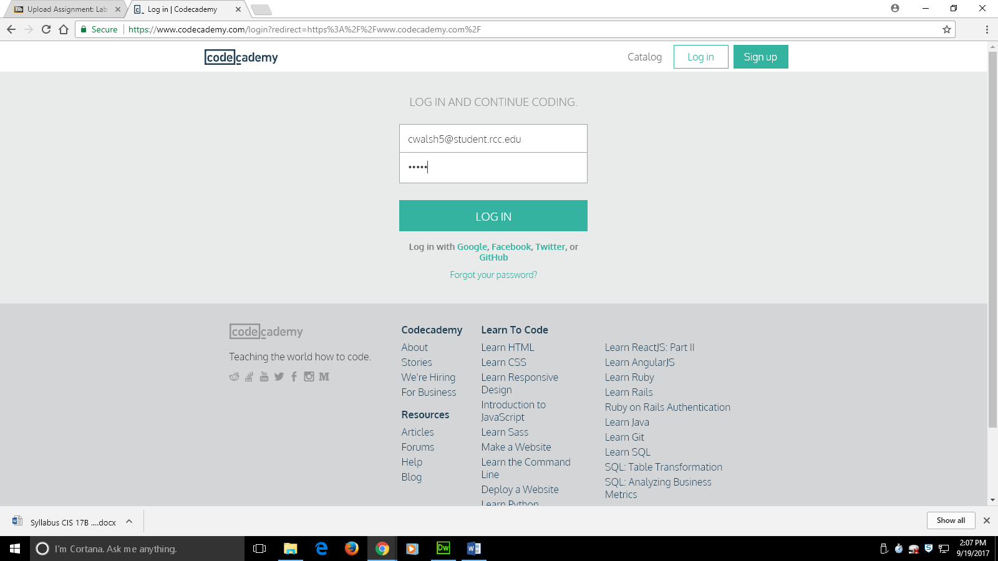

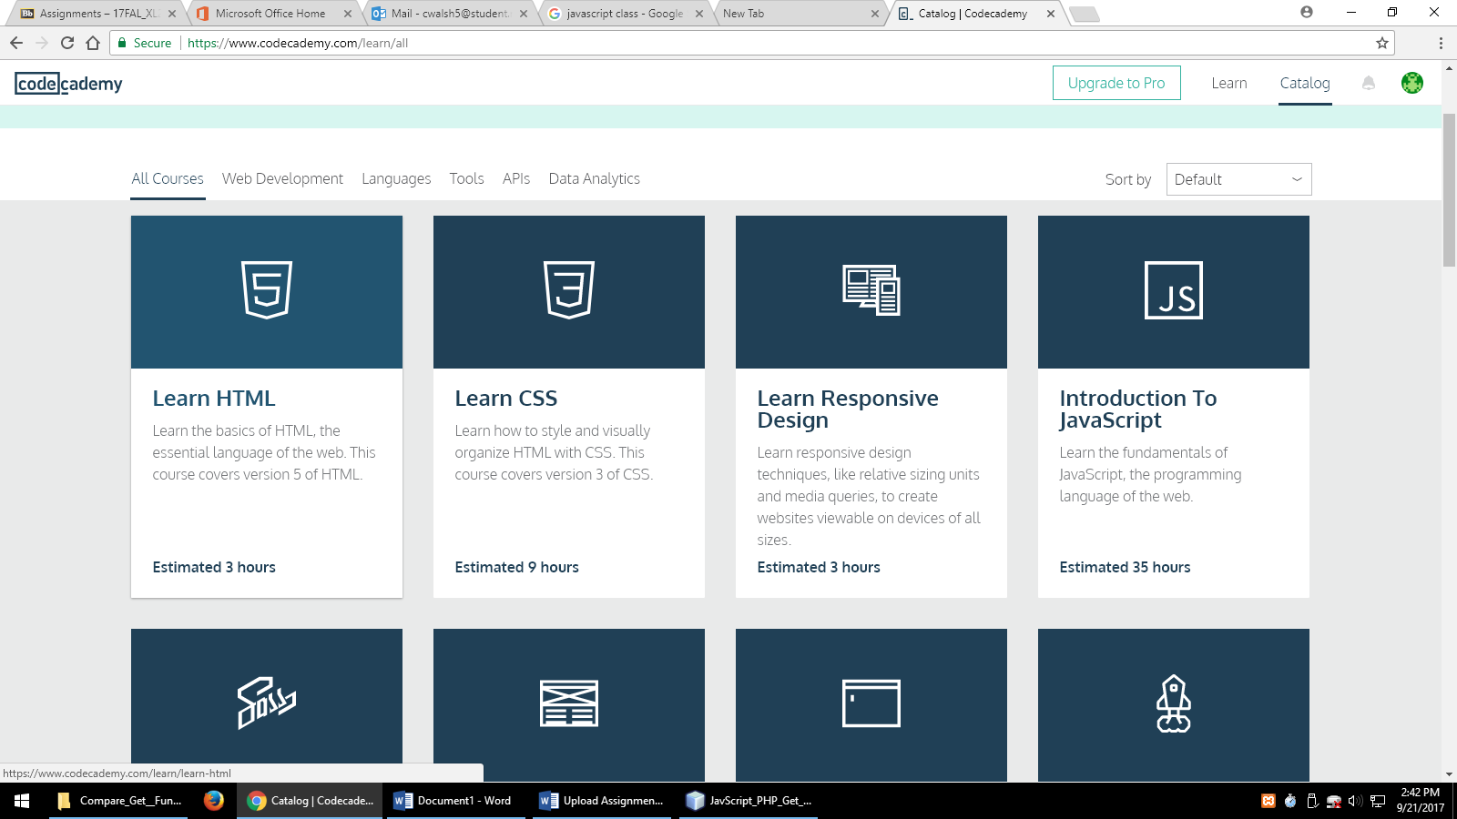

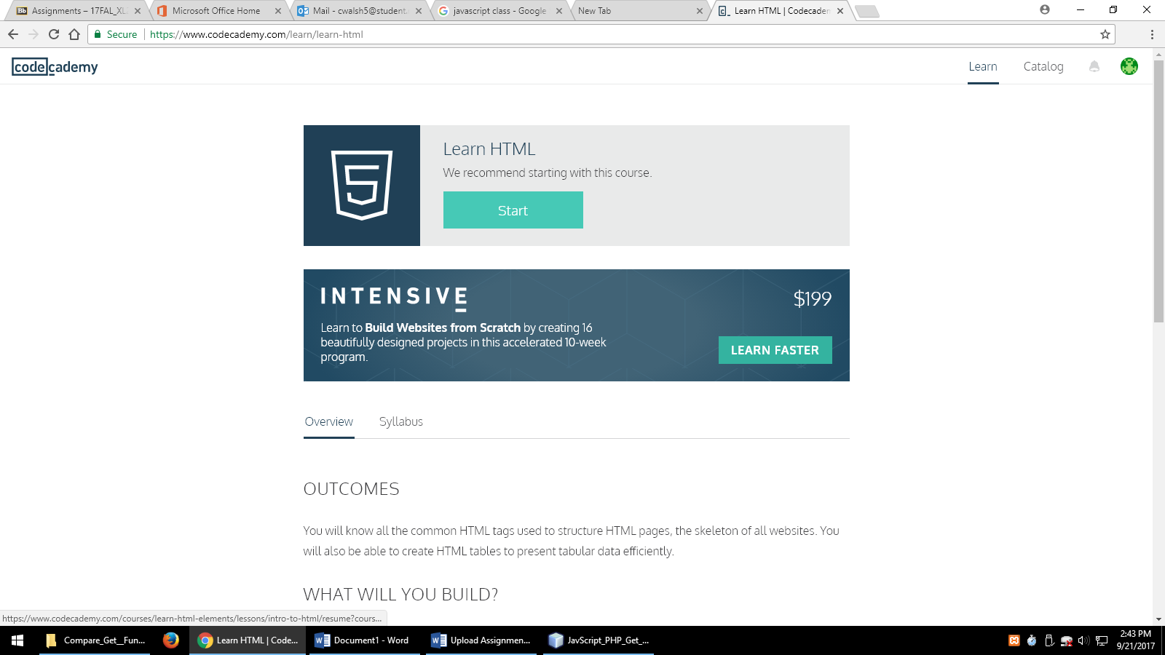

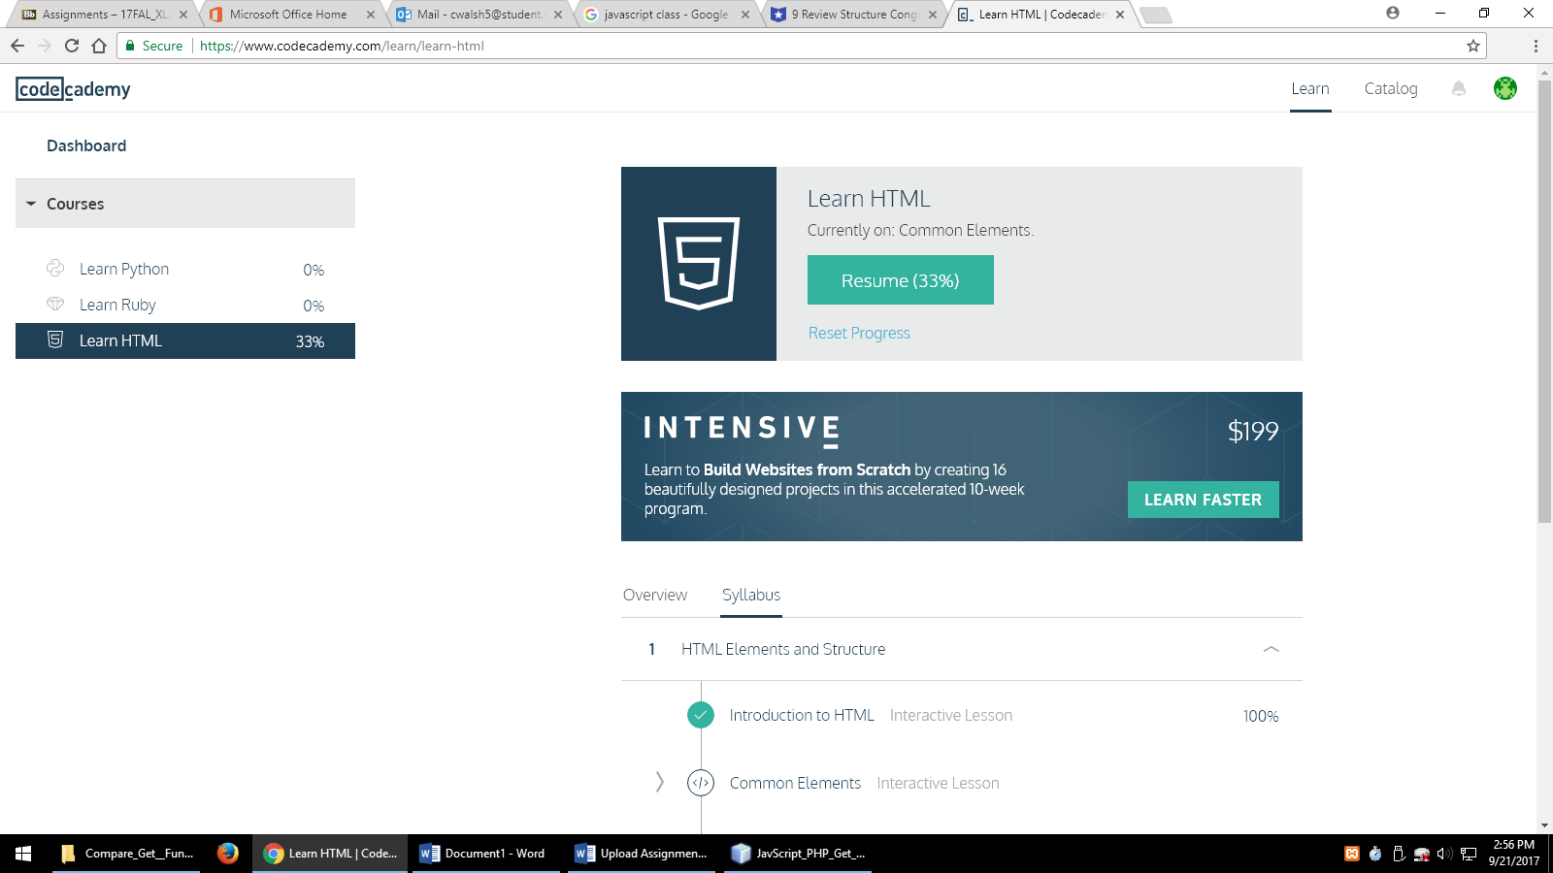

1. Do the Learn HTML course.
2. Also do the HTML5 tutorial at <https://www.w3schools.com/html/> Review the left tabs from HTML 5 home to HTML Blocks.
3. Take a screen shot of your completion of code academy. Take a screen shot of each tutorial from w3schools you complete. Create a folder and place all screen shots in folder. Zip the folder and submit in blackboard as well as copying yourself on an email to mark.lehr@rcc.edu with subject:

YourLastName, YourFirstName - Lab 1 - 47340 or 48947